Student’s name | …………………………………………………….…… | Grade | 4
Subject | Computer | Week No. | 14
Lesson Title | Spreadsheet Formulas | Unit
Worksheet No. ( 14 )

Question A: Write the correct name of each part.

Excel Logo | Spreadsheet

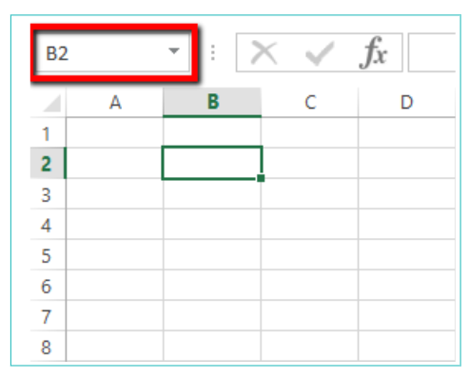
Good Luck

